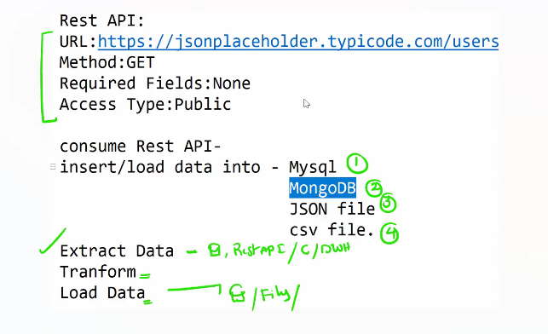

Invoke rest api 🡪 using request

Rest api testing tool – postman

https:// jsonplaceholder.typicode.com/users

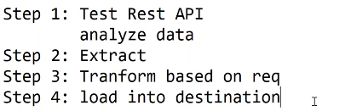

Create table users(

uid int not null,

uname varchar(50),

city varchar(50),

phone varchar(50),

email varchar(50)

);

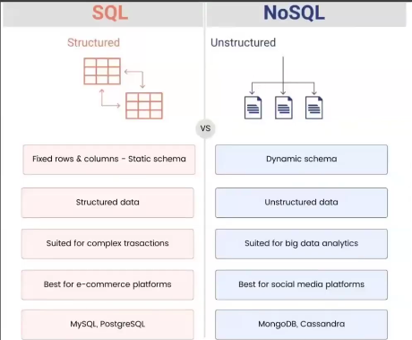

1. Extract the Data :

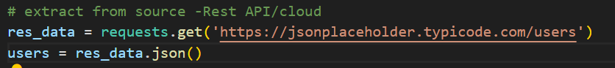

1. Transform the Data :

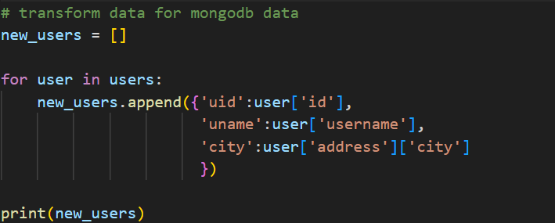

1. Load the data

